Chapter

5

Quality, Usability, and the Value Proposition

Blake Lesselroth, MD, MBI

Kathleen Adams, MPH

Ross Speirs, PhD

In this section, we describe organizational strategies that should be part of every team’s toolkit. We highlight using a “customer grid” to organize metrics and a testing plan.

I

rrespective of scope – whether a large-scale software development initiative or a re-appraisal of a purchased technology – every project needs a clear game plan. This game plan includes **a sponsor** (i.e., the project owner), a **problem statement** (i.e., the issue that you must fix), and a **measurement strategy** (i.e., how you collect, analyze, and report your findings). It is crucial to write down this strategy in terms that resonate with stakeholders (particularly your benefactor) that trace your work to an organizational **value proposition**. Stated simply, how will a usability assessment generate a return-on-investment by improving patient outcomes, user performance, or organizational effectiveness?

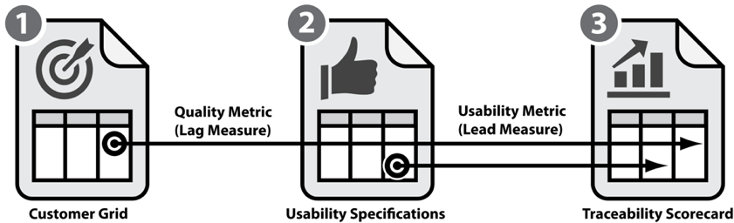We’ve included a case study to illustrate how our team defines usability and communicates a measurement plan to stakeholders. We introduce three tools to organize work: (1) a **customer grid** to select quality metrics; (2) a **usability specification table** to clarify usability expectations; and (3) a **usability-goal traceability scoreboard** connecting usability to quality and project goals(**Figure CS 1.1**). Different stakeholders gravitate to specific tools; sponsors may care most about the customer grid defining business goals whereas developers may prefer the usability specifications table to inform design work.

**Figure CS 1.1.** Overview of the instruments and relationships described in this case study.

## 

## Case Study Project Brief

The National Program Office of Emergency Medicine within the Department of Veterans’ Affairs sponsored an initiative to standardized patient encounter documentation in emergency departments (**Figure CS 1.2**). At baseline, ED departments in VA hospitals could design their own note templates for documenting patient encounters. This distributed governance empowered local stakeholders to customize templates according to local needs. However, this also permitted wide variability across the enterprise. Therefore, it was difficult to standardize new initiatives (such as a pandemic screen-and-treat program), aggregate data for performance dashboards, or compare quality and volume between sites.

The project had four high-level business goals: (1) the note should improve interprofessional communication (e.g., nurses to physicians; emergency departments to inpatient wards); (2) it should capture structured data on diseases and treatments for analytic reports; (3) it must support accurate coding for reimbursement; and (4) it should reflect clinical decision making. Recognizing the inherent challenge of large-scale change management, The VA retained the Office of Human Factors Engineering (OFE) to collect meaningful requirements, provide template specifications, and test prototypes.

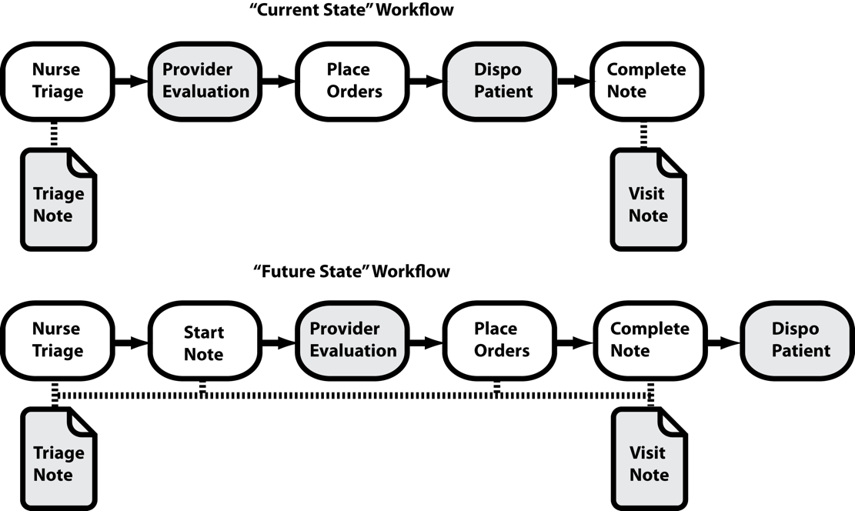

**Figure CS 1.2.** Current state and future state of ER documentation project. In the current state, the nurse and provider generate separate notes. The provider typically generates a note at the end of the visit; provider time and recall limit the quality of documentation. In the future state, provider and nursing activities populate multiple notes in “real-time” – including the summary visit note. The provider appends this note with any events (e.g., outcomes, disposition) that occur after generating the note. This approach captures more information, limits duplicative efforts, and increases situational awareness between team members.

## The Value Proposition

We often speak of the “value proposition” without a shared definition among stakeholders or a clear understanding how to communicate the value of UX work to leadership. In organizations with low UX maturity (frankly, most organizations), a lack of transparency can jeopardize funding of UX work or implementation of important usability findings. Therefore, to secure continued support and engage clinical champions, it is crucial to articulate how each UX activity such impacts the bottom line.

Many experts credit the term “value proposition” to Lanning and Michaels. In their seminal paper “A Business is a Value Delivery System” they state, “[the value proposition is] a clear, simple statement of the benefits, both tangible and intangible, that the company will provide, along with the approximate price it will charge…for those benefits (Lanning & Michaels, 1988).” In terms of UX work, the value proposition is a succinct statement clearly describing measurable benefits an organization gets by including UX activities in the product development lifecycle. The value proposition should convince leaders that investing time, money, or personnel in a UX evaluation will increase the probability of meeting performance measures. It should also convince end-users to adopt your product over competitors – or resigning to the status quo.

Since stakeholders must be involved to define and validate the value proposition, there are several questions worth asking at project kickoff.

* What problem do you intend to solve?
* Who does the problem affect and how is it measured?
* What is the organization currently doing and why is it not enough?
* What is the proposed solution?
* How will project sponsors define or determine success?

It is often best to interview several representative stakeholders before developing metrics by using a semi-structured interview script with additional probes (included in the Appendix).

As an example, an outpatient mental health treatment facility may seek to improve the quality of psychotherapeutic care for depression. In the current state, the facility does not require providers to use a standardized format to document care. Therefore, the facility leadership cannot see whether the treatments clinicians select for patients improve clinical outcomes. So long as facility leaders accept the status quo, it will be difficult to determine which patients are making progress or should be offered different care. Leadership proposed developing a template that captures the condition, the treatment, and a patient-reported numerical depression score. Leaders will estimate template success by studying (1) the proportion of notes with all three elements (i.e., effectiveness); (2) the time required to complete a note (i.e., efficiency); and (3) user adoption rates (i.e., satisfaction).

There are few final points that we need to make about the value proposition. First, reaching consensus can be challenging with many stakeholders or an organization with de-centralized leadership. Second, stakeholders may not have a clear definition of success at the outset of the project. In both these situations, it is our job to help clarify what success looks like and to align measures among stakeholders. Hence, getting to a final metrics plan can take several iterations. Finally, when benefactors insist upon calculating the costs and benefits of UX work in financial terms, a reductionist approach can be necessary. In these situations, define a metric in terms of money and look at the financial costs and gains associated with a redesign (Nielsen, 2003). In the private sector, organizations tend to spend 10-13% of a project budget on usability and a suggested industry best practice is 10%. Through most organizations measure return in different units, such as product adoption, time on task, conversion to sales, or user satisfaction, converting dimensions into a financial amount is a relatively simple matter. For example, determine the average difference in time on task and then multiply by the cost per employee and total number of employees affected. Although, Nielsen writes that in gross terms, a 10% investment usually doubles usability, he also points out that this is rarely a linear relationship. As the size and cost of the project increase, usability benefits very quickly scale up. We will focus more upon return-on-investment later in later chapters.

## Transforming Business Goals into Measures

We must transform each business goal should into a measure we can count. **Table** **CS 1.1** indicates how we converted the business goals into quantitative measures. Some of the measures reflect the proportion of successful events divided by all opportunities, whereas others are counts of defects or process failures. Some goals are composites of several measures. Once we have the main measures and we have a sense of the future state workflow, we can begin to populate a customer grid. The customer grid provides additional context by embedding these critical measures within a larger project plan so that stakeholders understand how all the pieces of a project fit together, recognize important relationships, and identify other measures that may be important to stakeholder buy-in.

Table CS 1.1. Mapping the high-level business goal to key quality measures identified in the customer grid for overall quality.

|  |  |
| --- | --- |
| Business goal | Key quality measure |
| Note supports accurate coding and billing | encounters with accurate documentation  all encounters seen in ER |
|  | *plus* |
|  | encounters where documentation matches codes  all encounters in ER |
| Leaders can mine data in notes | encounters where all diagnoses evaluated during  visit are documented in note using structured fields  all encounters in ER |
| Note improves communication between providers | number of notes completed before hospitalist  assessment and with primary care provider copied to note  all encounters in ER |
| Note supports decision making | number of medication discrepancies on first inpatient day  for all patients admitted from ER |
|  | *plus* |
|  | number of patients receiving  follow-up call within 3d of ER evaluation  all patients seen in ER and discharged |

## Customer Grid

Individuals implementing any innovation need to clearly articulate their quality goals, the customer’s expectations, measures of success, and methods for collecting and displaying data. This is equally true for usability work. The **customer grid** is a longstanding technique based upon statistical process control methods used in healthcare quality improvement (Seidl & Newhouse, 2012). The World Health Organization promotes the grid to illustrate how process control measures trace back to customer expectations and business goals (World Health Organization, 2011). It is an efficient way secure buy-in by showing the association between business goals, customer goals, influenceable metrics, and measurement methods.

Typically, before we develop a grid, we have a general understanding of the workflow. The current state workflow enables us to quickly identify the key process steps we want to change in the future state to achieve our quality goals. In **Figure CS 1.3**, we have a future state workflow that shows how different steps of the patient encounter populate the note. We use these process steps to fill out the first column of our customer grid (**Table CS 1.2**).

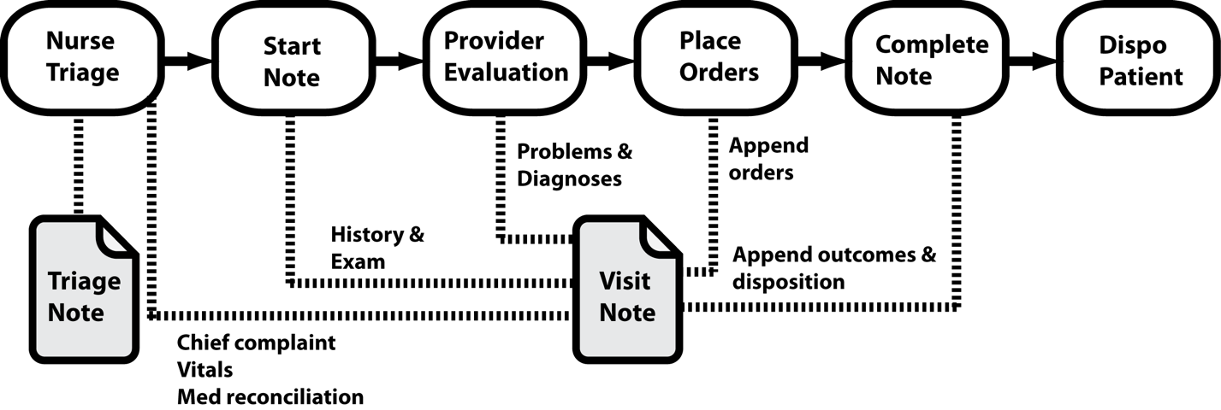

**Figure CS 1.3.** Future state workflow (detailed) and process steps for the ER documentation project. The revised product captures chief complaint, medication discrepancies, structured diagnoses, and a summary of treatments. Ideally, the components permit the provider to complete note so that it is available in the next setting of care.

We have included an example of a customer grid for documenting an emergency room encounter. The business goals – (1) support accurate coding and billing; (2) capture structured data; (3) support clinical decision making; and (4) foster communication – were not originally in a measurable form. To convert them into metrics, we listed the process workflow and key process steps (shown in the left column). We then identified the “customers” for the output of each step. We quantitatively described what it meant to meet customer’s expectations. This measure of success is the **key quality characteristic** or **key performance indicator** (listed in the second from right column) (Carey & Lloyd, 1995). Finally, we identified the best display metric for a dashboard or report card (right column). We will explore these display methods in future chapters.

TAble CS 1.2. Example customer grid outlining the goals and measures for an emergency medicine note template (adapted from the WHO). Although we outline the entire workflow, the bold text identifies the metrics that operationalize the sponsor goals.

| Process step | Desired outcome | Customers for process | Customers’ expectations | Measure of success | Best display method |
| --- | --- | --- | --- | --- | --- |
| Nurse interviews and triages patient | Nurse gathers timely and accurate information from the patient | Patient  ER provider* | Nurse completes a medication review with patients  Nurse gathers information before ER provider assessment, so that it is available at time of assessment | % of encounters where nurse attempted to collect a medication and allergy history  % of time nurse assesses patient at least 15 minutes before ER provider* | p chart  p chart |
| Nurse documents in EHR the chief complaint, vital signs, and medication history* | Nurse documents the exact chief complaint and MR in EHR before ER provider starts note; uploads vital signs to EHR before ER provider starts note* | ER provider* | Nurse documents’ chief complaint  Nurse documents a complete MR and updates allergies in EHR before ER provider writes orders  Nurse collects vitals for review before ER provider sees patient | % of nurse notes with chief complaint entered before ER provider note started  % of encounters with MR documented before ER provider note started  % of encounters with vital signs entered before ER provider note started* | p chart  p chart  p chart |
| ER provider assesses patient and writes orders | ER provider has all clinical information available to write safe, accurate, and appropriate orders | ER provider  Patient  Pharmacist | The ER provider can immediately review MR history and vital signs  The patient receives correct medications for disease without untoward reaction  The medication history and allergy lists are available when pharmacists verify orders. | # of times the MR or vitals were unavailable before ER starts assessment  # of adverse medication reactions despite a documented medication allergy  # of times pharmacist calls ER provider for change in orders based upon documented allergy | u chart  G chart  u chart |
| ER provider writes EHR encounter note | ER provider starts note with pre-populated data fields and can complete note efficiently | ER provider  Hospital provider or PCP*  HIMS  Enterprise executive | Parts of the note are automated  ER provider can quickly enter a note  **The next provider knows the clinically important events when patient arrives to clinic or ward**  **The documentation supports the complexity of care reported**  **The executive can run a report showing diagnoses managed in ER** | % of ER provider notes that include MR, vitals, and chief complaint  Total time required for ER provider to complete note  **% of ER encounters with notes completed and PCP identified as additional signer before hospitalist evaluation**  **% of ER encounters with accurate documentation**  **% of ER encounters where structured diagnoses in documentation match diagnoses managed** | p chart  histogram  p chart  p chart  p chart |
| ER provider completes EHR encounter form | ER provider documents the correct complexity of care | HIMS  Enterprise executive | **The ICD-10, CPT codes, and resident supervision modifiers permit billing at highest appropriate level**  **The ICD-10, CPT codes, and resident supervision modifiers accurately reflect complexity of care** | **% of ER encounters with codes that match the complexity documented in notes**  **% of ER encounters where structured diagnoses in documentation matches coded encounter forms** | p chart  p chart |
| HIMS reviews note and encounter form | HIMS submits documentation to third party insurers to collect for ER services rendered | Payors  Enterprise executive | Documentation supports the amount of reimbursement claimed  Payors approve and reimburse for all services rendered | # of claims denied  Revenue generated from ER encounter reimbursements per month* | u chart  XmR chart |
| Next provider reviews details of ER encounter | Next provider of care receives timely summary of ER encounter | Patient | **Patient receives appropriate and timely care** | **# MR discrepancies on first inpatient day**  **% of patients discharged from ER receive follow up calls from clinic within 3d of visit** | u chart  p chart |

Electronic health record (EHR); emergency room (ER), health information management specialist (HIMS); medication/allergy reconciliation (MR); primary care provider (PCP)

There are several important points to emphasize with this grid. First, we highlighted measures that directly link to the business goals. In some cases, we had to define the business goals with greater specificity. For example, where the business goal said the note “should improve communication between providers”, we operationalized it to mean “The next provider of care knows the clinically important events – based upon a completed note – when the patent arrives to the clinic or ward.” We can measure this in several ways. We could conduct chart reviews to confirm the treating clinician recorded all diagnoses and treatments. We could confirm authors signed notes into the record before transferring patient to the ward. We could survey inpatient staff or primary care providers asking if the note met their needs. Second, we described the end-to-end process and included many steps that do not directly involve use of the ED note template or our business goals. Nevertheless, it is important to recognize system relationships and dependencies. We need to know how the ED note interacts with all processes and stakeholders. Finally, we added additional quality measures for each process step. While we may not collect all these measures, it helps us see which measures might be relevant to different stakeholders or be important levers of change. Bottom line, the quality of the customer grid is not dependent upon the exact measures selected. Frequently, it is a choice of preference, politics, resources, or logistics. It is more important to document a structured approach and produce a blueprint that effectively maps out and communicates the project.

## Usability Specification Table

In the last example, we developed a clear idea of the business goals and performance measures. However, these are not necessarily UX metrics; they are quality metrics. Quality metrics reflect the performance of a system, whereas UX metrics characterize the interaction between the user and the device. UX measures are specific to the human-computer interface. In the example above, many measures represent system outputs, but may not reflect user perceptions. This is an important distinction because both user perceptions and outputs influence system performance. In the Effective Technology Use (ETU) model, we see that user perceptions of the interface directly influence use of the product (**Figure CS 1.4**) (Holahan, Lesselroth, Adams, Wang, & Church, 2015). If the system is not performing, the root cause may relate to UX.



**Figure CS 1.4.** The Effective Technology Use model describing factors mediating technology adoption.

It is important to explicitly measure UX dimensions most likely to impact user perception, adoption, and performance. To do this, use a common method for operationalizing usability by building a **usability specification table** (Albert & Tullis, 2013). The table aligns UX dimensions with metrics and data collection methods. Each row in the table defines a range of values with thresholds for failure and success. While the team may not actually measure every attribute, seeing all dimensions in one place is useful for identifying design trade-offs. In **Table CS 1.3**, we list potential UX measures for the ER template. We included the three measures of usability described by the International Organization for Standardization (ISO) – **effectiveness**, **efficiency**, and **satisfaction** – and additional measures described by Whitney Quesenbery including **desirability**, **error** **tolerance**, and **learnability** (Barnum, 2010). In this example, we included one additional measure looking at **ease-of-use** because it maps to the ETU model. However, we could have used a composite of other measures, such as **efficiency** and **learnability**, to operationalize ease-of-use. Notably, we did not include other usability measures often important in healthcare – **safety** and **trustworthiness**. These tend to be salient in studies of decision support, data visualization, or therapeutic delivery systems.

TAble CS 1.3. Example usability specification table for an emergency medicine note template (adapted from Albert & Tullis).

|  |  |  |  |  |  |  |
| --- | --- | --- | --- | --- | --- | --- |
| Usability dimension | Measured value | Measurement instrument or method | Baseline performance  (pre-implementation) | Target performance  (post-implementation) | Worst acceptable level  (post-implementation) | Best display method |
| Effectiveness | Notes include chief complaint, MR, allergies, diagnoses, treatments administered, and PCP notification | Chart abstraction instrument with double-pass verification by two trained reviewers | 80% of notes include all six elements | 95% of notes include all six elements | 80% of notes include all six elements | Stacked bar chart |
| Efficiency | Number of mouse clicks to complete note | Mouse and keystroke collection using screen recording software | Average 5 mouse clicks with standard deviation of 2 clicks | Average 5 mouse clicks with standard deviation of 2 clicks | Average 7 mouse clicks with standard deviation of 2 clicks | Paired frequency distribution |
| Engaging  (i.e., desirability) | Average score | Net Promoter Score | Score +25 | Score > 35 | Score < 0 | Stacked bar charts of promoters, passives, and detractors |
| Error tolerance | Number of dialog elements that ER provider cannot complete | Direct observation with ordinal scale for errors | No errors or assists | No errors or assists | No errors; less than 2 assists | Frequency distribution |
| Learnability | Length of time required to complete ER note over three successive trials | Time-motion data collected with screen recording software | Average time per note 7.5m and no note longer than 10m | Average time per note 7.5m and no note longer than 10m | Average time per note 8m and no note longer than 12m and all notes complete | Frequency distribution of geometric means plotted over trials |
| Satisfaction | Average overall score | Post-session SUS | Overall average score 80 | Overall average score 80 | Overall average score 70 | Frequency distribution |
| Ease-of-use | Average score | Post-session SMEQ | Average score 15 | Average score 15 | Average score 35 | Frequency distribution |

Emergency room (ER); primary care provider (PCP); System Usability Scale (SUS); Subjective Mental Effort Question (SMEQ)

## Goal Traceability Scoreboard

We need to combine our quality and usability measures into one coherent performance plan. Frequently, high level goals and performance metrics are important to the organization but they are not directly influenceable. Conversely, we can manipulate the interface to influence usability metrics, but they don’t always move the needle on enterprise performance goals. To demonstrate a return-on-investment, we must link these proximal influenceable UX measures (i.e., **lead measures**) to downstream enterprise performance measures (i.e., **lag measures**). To do this, we will use a scoreboard called a **goal traceability matrix**. Based upon McChesney and colleagues’ business execution strategy, the matrix helps identify what actions are needed that will increase the probability of achieving your strategic goals (McChesney, 2012). **Table CS 1.4** is an example of linking lead UX measures to lag performance measures. In this example, we selected the four lag measures (i.e., key quality characteristics from our customer grid) described in the project brief and four lead measures from our specifications table that trace clearly to our strategic goals. It is rarely necessary to map every usability measure or every quality measure. Instead, consider holding measures “in reserve” and act only in future project phases or as program objectives evolve.

TAble CS 1.4. Example goal traceability matrix linking strategic goals to lead measures and lag measures (adapted from McChesney).

|  |  |  |  |  |  |
| --- | --- | --- | --- | --- | --- |
| Strategic goal | Lag measure  (key quality characteristic) | Lead measure  (usability specification) | Metric | Collection method | Display statistic |
| Note improves communication between providers | % of ER encounters with notes completed and PCP identified as additional signer before hospitalist evaluation | Learnability or efficiency of note completion | Length of time required to complete ER note | Time-motion data collection using screen recording software | Frequency distribution of geometric mean |
| Note supports decision making | # MR discrepancies on first inpatient day | Effectiveness capturing key clinical data | Notes include chief complaint, MR, allergies, diagnoses, treatments administered, and PCP notification | Chart abstraction instrument with double-pass verification by two trained reviewers | Stacked bar chart |
| Note supports accurate coding and billing | % of ER encounters with accurate documentation | Satisfaction with system usefulness, information quality, and interface quality | Average overall score | Post session SUS | Frequency distribution |
| Note can be data mined by leaders | % of ER encounters where structured diagnoses in documentation match diagnoses managed | Error tolerance for entering structured diagnoses data | Number of dialog elements that ER provider cannot complete | Direct observation and ordinal scale for errors | Frequency distribution |

Emergency room (ER); primary care provider (PCP); medication and allergy reconciliation (MR); System Usability Scale (SUS).

In the scoreboard above, we organized each row according to the high-level strategic goals of the project brief. This may make the most sense in command-control or hierarchical organizations where senior executives and management set priorities and project budgets. However, many healthcare organizations may have a matrix structure with multiple managerial accountability, several core competencies (e.g., care delivery and health advocacy), or a horizontal network of clinical stakeholders with relative autonomy (e.g., hospitalists and surgeons). In these situations, it may make sense to organize the scoreboard according to key stakeholders, where each row of the table captures the relevant pain point, goal, or lever of change (**Table CS 1.5**).

TAble CS 1.5 Example of goals traceability matrix organized by each customer traced through to the value proposition.

| End user | Problem or scenario | Stakeholder expectation | Baseline usability performance | Target usability performance  (lead measure) | Quality impact or business goal  (lag measures) | Assessment strategy |
| --- | --- | --- | --- | --- | --- | --- |
| ER triage nurse | Nurse needs to accurately document medications, allergies, chief complaint, and vital signs | Nurse efficiently documents the chief complaint,  MR, vital signs, and allergies in EHR before ER provider sees patient | Nurse completes each note in less than 10m | Nurse completes each note in less than 10m | % of ER provider notes that include MR, vitals, and chief complaint | Observation and time motion |
| ER provider | Provider needs to enter the information as quickly and easily as possible | The notes efficiently captures the complexity of care, clinical impressions, and plan | Average time per note 7.5m and no note longer than 10m | Average time per note 7.5m and no note longer than 10m | % of ER encounters where structured diagnoses in documentation match diagnoses managed | Time-motion data collection |
| Pharmacist | The correct allergy list, medication list, and clearance are available | The pharmacist has a medication history and allergy list available when confirming orders | 80% of nurse or ER provider notes include allergies and MR | 95% of nurse or ER provider notes include allergies and MR | # of clarification calls placed by pharmacist to physician | Chart abstraction instrument with double-pass verification by two trained reviewers |
| Next provider in care | Provider needs to be able to readily find key information to support decision making | The next provider knows the clinically important events | Overall average score 60 | Overall average score 80 | % of ER encounters with notes completed and PCP identified as additional signer before hospitalist evaluation | Post session SUS |
| Patient | The patient receives correct medications and therapies | Patient receives appropriate and timely care without disruption in continuity | 80% of notes include diagnosis, treatments administered, and PCP notification | 95% of notes include diagnosis, treatments administered, and PCP notification | # MR discrepancies on first inpatient day | Chart abstraction instrument with double-pass verification by two trained reviewers |
| HIMS | The documentation must support the highest level of billing possible | Documentation supports the amount of reimbursement claimed and payors reimburse for all services rendered | 70% of ER encounter codes match complexity documented in notes | 90% of ER encounter codes match complexity documented in notes | % of ER encounters with codes that match the complexity documented in notes | Chart abstraction comparing notes with encounter forms |
| Executive | The documentation must permit abstraction of coded diagnoses | The ICD-10, CPT codes, and resident supervision modifiers accurately reflect complexity of care for staffing and resource planning | Average SMEQ score 15 | Average SMEQ score 15 | % of ER encounters where structured diagnoses in documentation matches coded encounter forms | Observation, chart abstraction and post-session SMEQ |

Medication reconciliation (MR); electronic health records (EHR); emergency room (ER); primary care provider (PCP); Computer System Usability Questionnaire (CSUQ); Subjective Mental Effort Question (SMEQ)

## Scoping and Prioritizing Work: Core vs Adaptable Periphery

We need to make several important points about scoping and prioritizing work. As we mentioned earlier, we identified many more measures during creation of the customer grid and the usability specification table than time or resources would allow any project team to collect. In fact, the narrower the scope of the project, the greater the likelihood of successfully completing the project on time and on budget. Like a battle-hardened general scanning a map of military fronts, you want to have a comprehensive map of your project and the vision to not only identify all the dependencies and risks to project success, but also to identify research opportunities, levers of influence, or pivot points if leadership changes courses. At any given time, however, you need to consolidate your effort and resources for the greatest impact.

There are a few techniques that can help think about scope and priority. First, Laura Damschroder and colleagues introduced the concept of **core components** and **adaptable periphery** in their Consolidated Framework for Implementation Research (CFIR) (Damschroder et al., 2009). In any implementation, there are core components that are essential and indispensable to the intervention. Without these components, the intervention breaks and the goals are not met. The adaptable periphery represents all the other elements, structures or systems related to the intervention and the organization that the implementation team may be at liberty to adjust to suit the context of implementation. For example, if implementing a tool to support clinic-based medication reconciliation, it may be necessary to create additional specialty-specific templates to encourage clinician adoption. The reconciliation element represents the core component and the associated template represents the adaptable periphery. The team can change the template based upon user feedback so long as the reconciliation module remains intact. It can be helpful to label items as core or periphery when taking an inventory of implementation components, process steps, and potential measures.

Another helpful strategy to limit scope is to have key stakeholders rank and select measures based upon the overall impact to the product goals. Sometimes the process can be as simple as holding a stakeholder meeting and discussing the measures in the context of resource constraints and scope. In small projects with fewer stakeholders, it may be a straightforward exercise to identify which measures are closest to the “revenue line” – meaning they are the measures or outputs that most directly influence organizational performance. Other times, there may be a large list of competing measures, stakeholders with deep investment in specific measures, or major resource constraints that make some data prohibitively expensive to collect (time-motion or eye-tracking, for example, is very labor intensive and costly to collect without sophisticated software). In these situations, a transparent way to prioritize measures is to convene the stakeholders for a forced-ranking exercise. Several authors have published such exercises and we will look at a few in later chapters. Finally, in very high stakes or politically charged settings, it can be necessary to use a formalized prioritization instrument that assigns scores and weights based upon the core competencies or values of an organization. For example, a healthcare organization may prioritize patient safety (measured in terms of medical errors) over interface efficiency (measured as time on task). A prioritization matrix is a table that stakeholders can use to list each project, feature, component, or metric. Then each item can be scored according to the a priori rating system, ranked according to priority, and published in a way that promotes organizational transparency.

## Conclusion

* Text here

## References

Albert, W., & Tullis, T. (2013). *Measuring the user experience: collecting, analyzing, and presenting usability metrics*: Newnes.

Barnum, C. M. (2010). *Usability testing essentials: ready, set... test!* : Elsevier.

Carey, R. G., & Lloyd, R. C. (1995). *Measuring quality improvement in healthcare: a guide to statistical process control applications*: ASQ Quality Press.

Damschroder, L. J., Aron, D. C., Keith, R. E., Kirsh, S. R., Alexander, J. A., & Lowery, J. C. (2009). Fostering implementation of health services research findings into practice: a consolidated framework for advancing implementation science. *Implementation science, 4*(1), 50.

Holahan, P. J., Lesselroth, B. J., Adams, K., Wang, K., & Church, V. (2015). Beyond technology acceptance to effective technology use: a parsimonious and actionable model. *Journal of the American Medical Informatics Association, 22*(3), 718-729.

Lanning, M., & Michaels, E. (1988). A business is a value delivery system. McKinsey & Company. *Inc., New York*.

McChesney, C. (2012). Preview of the four disciplines of execution. *Retrieved March, 13*.

Nielsen, J. (2003). Return on Investment for usability. Alertbox. In.

Seidl, K. L., & Newhouse, R. P. (2012). The intersection of evidence-based practice with 5 quality improvement methodologies. *JONA: The Journal of Nursing Administration, 42*(6), 299-304.

World Health Organization. (2011). *WHO Multi-Professional Patient Safety Curriculum Guide*. Geneva, Switzerland: WHO Press.